**NEURAL NETWORK DEEP LEARNING**

**ICP_4_SPRING24 ASSIGNMENT- 5**

NAME : JAYADEEP NAGUBATHULA

UCM ID: 700747518

GITHUBLINK:

<https://github.com/JayadeepNagubathula/ICP_5_SPRING24>

Video Link:

<https://github.com/JayadeepNagubathula/ICP_5_SPRING24/assets/156541783/1b6599cf-0acf-4032-b5ec-e353a27ba53b>

Navie Bayes Algorithm:

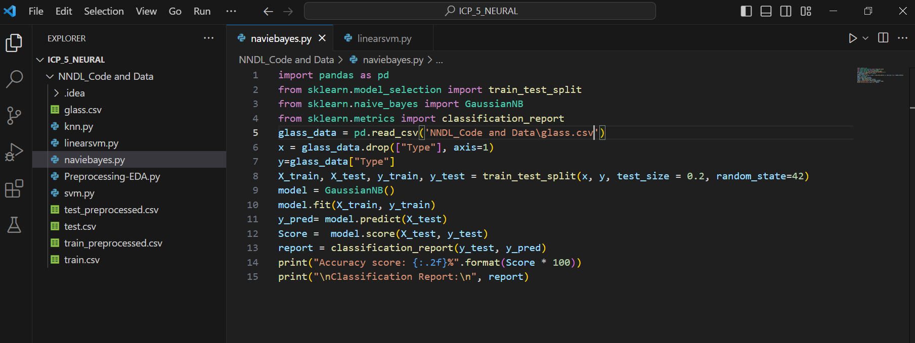

OUTPUT:

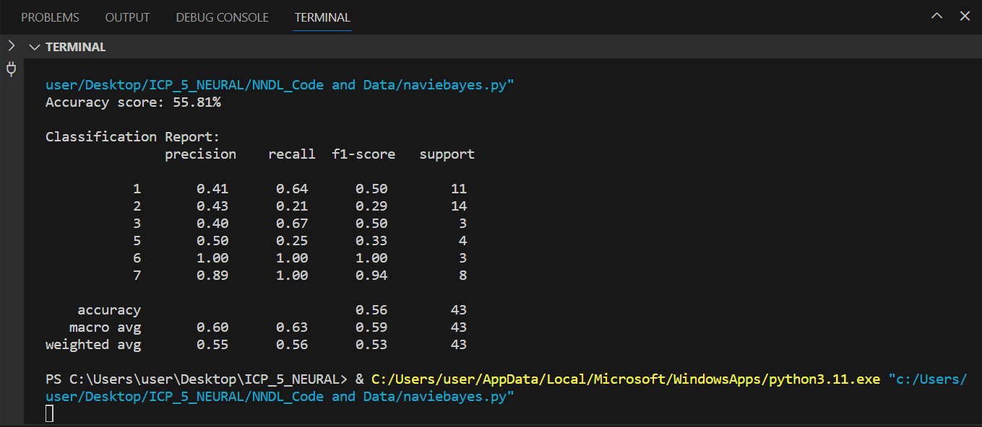

Linear SVM:

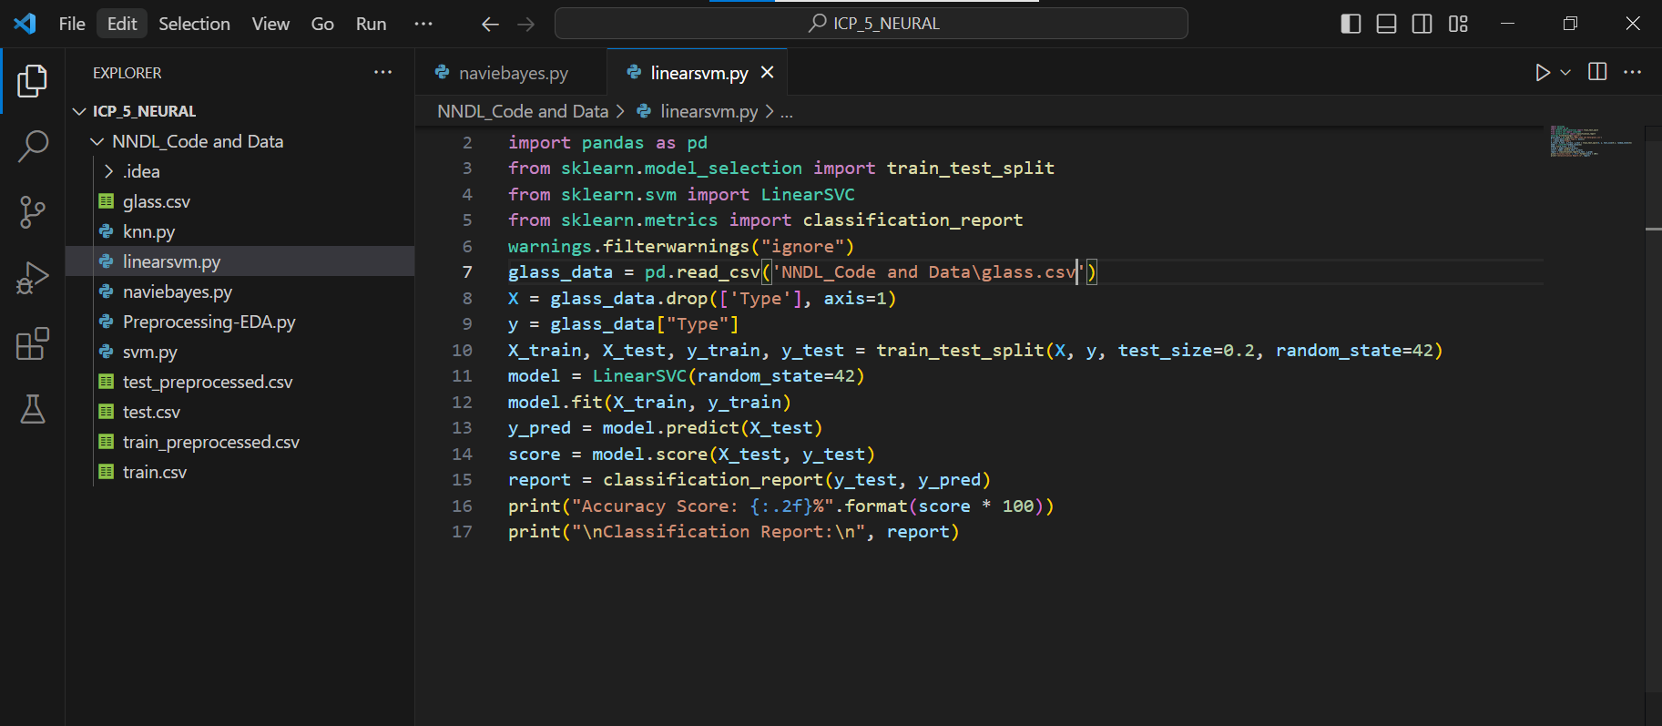

OUTPUT:

